Fork assembly instructions

Warehouse
 | 1 | 2 | 3 | 4 | 5 | 6 | 7
A | 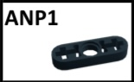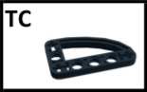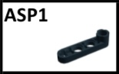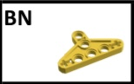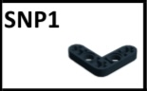 | 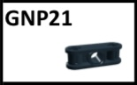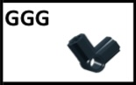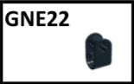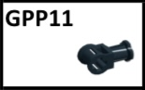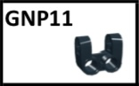 | 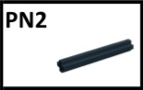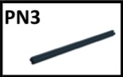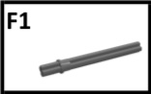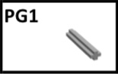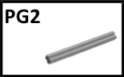 | 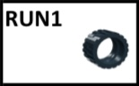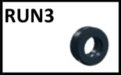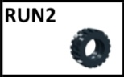 | 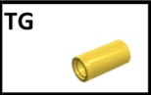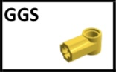 | 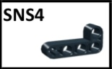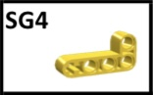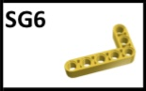 | 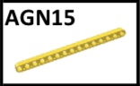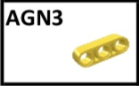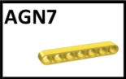
B | 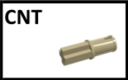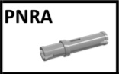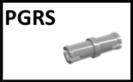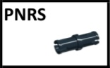 | 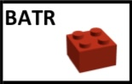 | 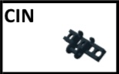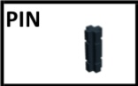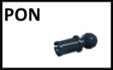 | 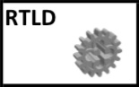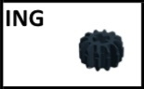 | 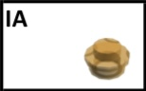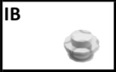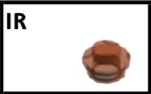 | 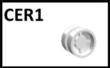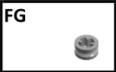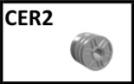 | 

List of parts needed
Take the following parts from stock:
- SNP1 (quantity: 2 pcs) à from shelf A1
- GPP11 (quantity: 2 pcs) à from shelf A2
- GNP21 (quantity: 1 pc) à from shelf A2
- GNE22 (quantity: 2 pcs) à from shelf A2
- PG1 (quantity: 2 pcs) à from shelf A3
- PN3 (quantity: 2 pcs) à from shelf A3
- F1 (quantity: 2 pcs) à from shelf A3
- PON (quantity: 1 pc) à from shelf B3
- ELA (quantity: 1 pc) → from shelf B7

Assembly

Step 1 - Withdraw Components for PIECE 1SARA
Required pieces for creating Piece 1SARA
- SNP1SARA x 29 pcsà from shelf A1SARA
- PG1SARA x 20 pcà from shelf A3SARA
Step 2 - Assembly PIECE 1SARA
Insert the two PG1SARA pieces into the holes of the two SNP1SARA pieces.
- Position the two SNP1SARA pieces so that the two 'L' shapes are mirrored, meaning, pointing in the same direction.
- Insert the two PG1SARA pieces into the cross-shaped holes located at the ends of the SNP1SARA pieces. The two gray axes should be centered into the two L-shaped pieces.

Step 3 - Withdraw Components for PIECE 2SARA
Required pieces for creating Piece 2SARA:
- Piece 1SARA
- GNE22 x 28 pcsà from shelf A2SARA

Step 4 - Assembly PIECE 2SARA
Creation piece 2SARA
- Insert the upper horizontal axis of Piece 1SARA into the cross-shaped holes of the two GNE22SARA pieces.
- Fully insert the two GNE22SARA pieces at the left and right ends of the upper axis.
- The protruding parts should be facing you and parallel to the axis of the SNP1 workpiece.

Step 5 - Withdraw Components for PIECE 3
Required pieces for creating Piece 3:
- Piece 2
- GPP11 x 2 pcsà from shelf A2

Step 6- Assembly PIECE 3
Creation Piece 3
- Insert the lower horizontal axis of Piece 1 into the cross-shaped holes of the two GPP11 pieces.
- Place the of the two GPP11 pieces at the left and right ends of the lower axis and insert them completely.
- Ensure that the hole in the protruding part of each GPP11 piece is aligned with the SNP1 axle , so that the hole is in line with the L-shaped piece.

Step 7 - Withdraw Components for PIECE 4
Required pieces for creating Piece 4:
- PN3 x 2 pcsà from shelf A3
- GNP21 x 1 pcà from shelf A2

Step 8 - Assembly PIECE 4
Creation Piece 4
1. Insert the two PN3 pieces into the holes of GNP21.
- Fully insert the two PN3 pieces into the two holes of GNP21. Once fitted, the 2 PN3 pieces should be parallel to each other and perpendicular to the GNP21 piece.

Step 9 - Withdraw Components for PIECE 5
Required pieces for creating Piece 5:
- PON x 1 pcsà from shelf B3
- Piece 4

Step 10 - Assembly PIECE 5
Creation Piece 5
1. Insert PON into Piece 4.
- Insert PON completely into the central hole of Piece 4 so that only the round part protrudes.
- Ensure that PON is perpendicular to Piece 4.

Step 11 - Assembly PIECE 6
Required pieces for creating Piece 6:
- Piece 3
- Piece 5
Creation piece 6
1. Join Piece 3 with Piece 5.
- Fully insert the two long sides (PN3) of Piece 5 into the remaining cross-shaped holes of Piece 3.

Step 12 - Withdraw Components for PIECE 7
Required pieces for creating Piece 7:
- Piece 6
- ELA x 1 pcà from shelf B7

Step 13 - Assembly PIECE 7
Creation piece 7
1. Attach the ELA elastic to Piece 6.
- Stretch the elastic ELA by fixing one end to the round part (PON) of Piece 6 and extending it to the low part of Piece 3.
- Fix the elastic ELA around the two pieces in the center (GPP11) and extend it to the bottom of the L-shaped part of Piece 3.

Step 14 - Withdraw Components for PIECE 8
Required pieces for creating Piece 8:
- F1 x 2 pcà from shelf A3
- Piece 7

Step 15 - Assembly PIECE 8
Creation piece 8
1. Insert the two F1 pieces into Piece 7.
- Fully insert the two F1 pieces into the front holes (GPP11) of Piece 7.
- Ensure to insert the side of the axis that has a small protrusion.
- The two F1 pieces should be perpendicular to piece 7.

Step 16 – Final Control/ Quality control
Control test
- Push down the part where the two gray axes (F1) are inserted and check If the movement creates tension in the elastic ELA.
- If the elastic does not create enough tension, make sure that all parts are properly assembled and that the elastic is not loose.

